Specifications
  - CTA-CR-012 PP - Assignment of Fixed Ship-To Address
Version 1.0

Customer: | CTA AG
Project: | New implementation of proALPHA
proALPHA version: | 9.3
proALPHA Installation(s): | CH-DE
GUI language: | German
Author: | Matthieu Staempfli
Created on: | 04.07.2024
Last change on: | 01.07.2026
Contact Customer: | Martin Weiß

This document describes a modification or expansion of the standard software proALPHA and has been checked by the customer. The functional design in chapters 2 - 4 is hereby released for technical specification and costing in compliance with the requirements in section "Final Provisions":

......................................................
Date and Signature of Customer

Contents
1. [UPDATE THE TABLE] 3
1.1 [UPDATE THE TABLE] 3
1.2 [UPDATE THE TABLE] 3
1.3 [UPDATE THE TABLE] 3
1.4 [UPDATE THE TABLE] 3
2. [UPDATE THE TABLE] 4
2.1 [UPDATE THE TABLE] 4
2.2 [UPDATE THE TABLE] 4
2.2.1 [UPDATE THE TABLE] 4
2.2.2 [UPDATE THE TABLE] 5
2.2.3 [UPDATE THE TABLE] 5
2.3 [UPDATE THE TABLE] 5
3. [UPDATE THE TABLE] 6
4. [UPDATE THE TABLE] 11
4.1 [UPDATE THE TABLE] 11
4.2 [UPDATE THE TABLE] 11
4.3 [UPDATE THE TABLE] 11
5. [UPDATE THE TABLE] 12
5.1 [UPDATE THE TABLE] 12
5.1.1 [UPDATE THE TABLE] 12
5.1.2 [UPDATE THE TABLE] 12
5.1.3 [UPDATE THE TABLE] 12
6. [UPDATE THE TABLE] 13
7. [UPDATE THE TABLE] 14
7.1 [UPDATE THE TABLE] 14
7.2 [UPDATE THE TABLE] 14
8. [UPDATE THE TABLE] 15

Requirements

References
- CR CTA-CR-012 PP - Assignment Fixed Ship-To Address.docx
- Concept Document Purchasing
- Sascha Kaiser, Sascha.Kaiser@cta.ch, 031 720 24 51
- Martin Weiss, Martin.Weiss@cta.ch, 079 252 10 36

Summary and Objectives
For suppliers, it must be possible to define that they have to deliver a specific ship-to address by default.
Objective: Automate the business process
- Minimize the risk of incorrect deliveries
- Optimized Use —> Reduced Input Time
ต้องสามารถระบุได้ว่าโดยค่าเริ่มต้นแล้ว suppliers จะต้องจัดส่งสินค้าไปยังที่อยู่จัดส่งที่ระบุไว้ เป้าหมาย: การทำให้กระบวนการทางธุรกิจเป็นไปโดยอัตโนมัติ
1. ลดความเสี่ยงของการจัดส่งสินค้าผิดพลาด
2. เพิ่มประสิทธิภาพให้สูงสุด --> ลดเวลาในการป้อนข้อมูล

Description of requirements
It must be possible to define for suppliers that they have to deliver a specific ship-to address by default.
ควรสามารถระบุได้ว่าโดยค่าเริ่มต้นแล้ว ซัพพลายเออร์จะต้องจัดส่งสินค้าไปยังที่อยู่จัดส่งที่ระบุไว้โดยเฉพาะ

Requirements Glossary (Terminology)

Term | Explanation
pA | proALPHA
Table 1Requirements Glossary

Functional design

Summary of the Solution
See above

Description of the solution

Business Logic & GUI
Actual situation:
There are suppliers who often have to deliver to the same ship-to address.
Several ship-to addresses of the company can be defined in the Purchasing area, e.g.:
- 0-Münsingen
- 1-Lausanne
suppliers บางรายมักต้องจัดส่งสินค้าไปยังที่อยู่จัดส่งเดียวกัน ในโมดูลการจัดซื้อ คุณสามารถกำหนดที่อยู่จัดส่งหลายแห่งสำหรับบริษัทได้ ตัวอย่างเช่น:
- 0-Münsingen
- 1-Lausanne
During the document entry, the correct ship-to address number has to be selected manually. CTA is not satisfied with this solution.
ระหว่างการป้อนข้อมูลเอกสาร ต้องเลือกหมายเลขที่อยู่จัดส่งที่ถูกต้องด้วยตนเอง CTA ไม่พอใจกับวิธีแก้ปัญหานี้
Target situation:
For suppliers, it must be possible to define that they have to deliver a specific ship-to address by default.
ควรสามารถระบุได้ว่าโดยค่าเริ่มต้นแล้ว ซัพพลายเออร์จะต้องจัดส่งสินค้าไปยังที่อยู่จัดส่งที่ระบุไว้โดยเฉพาะ
A "Ship-To Address" field should be available in the supplier master files under Parameters. A fixed ship-to address could be assigned there, e.g., "1-Lausanne".
ในข้อมูลหลักของซัพพลายเออร์ ภายใต้หัวข้อ “พารามิเตอร์” ควรมีช่องที่ระบุว่า “ที่อยู่จัดส่ง Anlieferadresse” สามารถกำหนดที่อยู่จัดส่งที่แน่นอนได้ เช่น “1-Lausanne”
The correct ship-to address is automatically used when the document is entered.
ระบบจะใช้ที่อยู่จัดส่งที่ถูกต้องโดยอัตโนมัติในระหว่างการประมวลผลเอกสาร
For example, "Lausanne" —> For this supplier, the ship-to address "Lausanne" is always suggested on the document.
Today, this option does not exist.
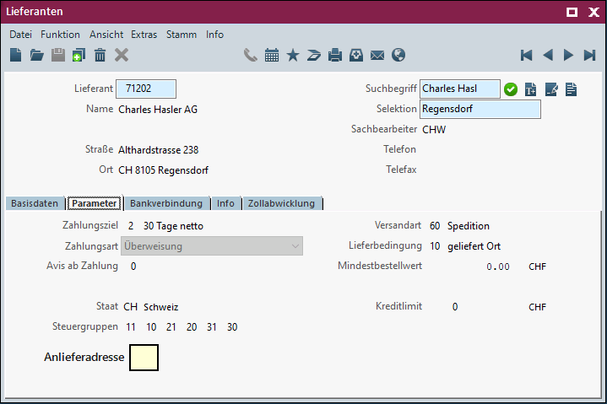
By pressing CTRL+A you have to open a browser to the ship-to address of the company.
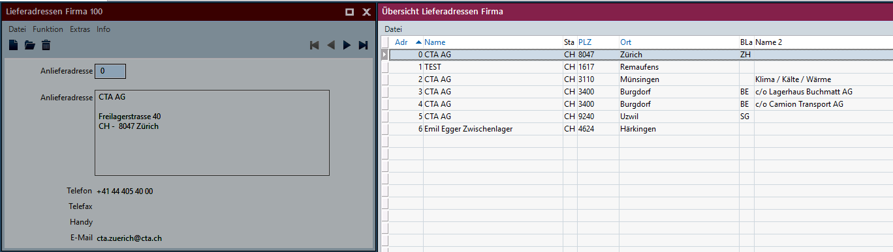

Data Model
- Provide xField

Output
- NA

Differentiation
The customization refers to the tables, fields and programs mentioned.
These specifications do not automatically add functional extensions to the modules of the proALPHA environment, such as the DMS, Analyzer, reports, and forms. The proALPHA Help is not automatically extended either.
Changes to adjacent modules/programs must be described and defined in the specifications sheet.

Test cases
The specified test cases map the customization described here and are the basis for the acceptance of the software.
Pt | Explanation | Expected result | Test data
 | Open Ship-To Addresses Company program | Program has been started
 | Test result (incl. screenshots)
 | Create new ship-to addresses of the company | New ship-to address has been created
 | Test result (incl. screenshots)
 | Assign the ship-to address to various customers | A ship-to address can be assigned to a customer A ship-to address can be assigned to a customer. CTRL+A works
 | Test result (incl. screenshots)
 | Enter and check order | The correct ship-to address has been determined in the document
 | Test result (incl. screenshots)
 | Test result (incl. screenshots)

Requirements

Technical Requirements
The use of proALPHA functionalities outside the concurrent user model (connection of external systems, background processing) requires the licensing of so-called software services.
"Use of proALPHA functionalities" refers to any use or access to the proALPHA infrastructure, e.g.
- Writing to proALPHA data structures
- Calling proALPHA classes and other business logic
- Opening proALPHA Services

Organizational Requirements

Notes about the go-live

Technical Design

Implementation
Create user exit "E_wbel05.xxw" from "E_ wbel05.w".
Add new virtual field "xAnlieferadresse" to table S_Lieferant. The field is to contain the ship-to address from "S_AnliefAdr. Determine "Delivery Address" (domain: "Delivery Address").
Functionality adoption of the ship-to address into the purchase order. E_BelegKopfAdr is filled with the document type and the reference number by E_BelegKopf. Address type must be "L". Determine S_Adresse from SB_Adr00.w and enter it in E_BelegKopfAdr -> BufferCopy.
CTRL-A in the App Builder -> Repository -> Help Functions -> Open Query and New Field
Insert the ship-to address from the S_Lieferant table, the Ship-To Addresses Company browser -> Overview Ship-To Addresses Company program. 

GUI
Add new field "Ship-To Address" for suppliers and documents.

Business Logic
Determine the ship-to address of the purchase order from the supplier master files (S_Lieferant_xAnlieferadresse).

Data Model

Final Provisions
These specifications form the basis for customer-specific extensions of the standard software proALPHA®.
The customer-specific extensions only cover the area defined in this specification sheet. Functionality beyond this scope is not provided.
Unless explicitly agreed otherwise, the customer-specific extensions are only created in German: no programs, program parts or data are translated into other languages. This also applies to the languages supported by ^{proALPHA®} in the standard version.
The customer-specific extensions are thoroughly tested before they are delivered. However, for technical reasons, it is not possible to perform the test under the same conditions and with the same data as the customer will use. It is therefore recommended to carefully check the functions in the real system environment after their delivery.
The Customer is aware that the transfer of the functions defined in this specification sheet to new versions of proALPHA® may require deviations in the display details or handling. This specification sheet also remains valid in this case, provided that there is a maintenance agreement for the customer-specific extensions defined in this specification sheet and no changes to the functionality have to be agreed on.
This specification sheet documents the customer-specific extensions. No other documentation beyond the specifications contained in this specification sheet is to be provided. Questions about customer-specific extensions are received and forwarded by the hotline.
By signing on page 1, you confirm:
that the specification sheet is accepted in this version and becomes part of the contract,
that this specification sheet defines the functional scope of the software to be created and that there are no side agreements regarding the functionality.

Annex

Table of Figures
No table of figures entries found.

Table of tables
[UPDATE THE TABLE] 3

Change History
Doc. -  Version | Date | Specialist | Initiator | Chapter | Explanation
1.0 |  | Matthieu Staempfli | Martin Weiß | All | Initial new entry

